Solution Architecture
Team ID | Date | Project | Maximum Marks
SWTID-2026-1237 | 30/09/2026 | EduGenie | 4 Marks

Solution Architecture
Solution architecture is a complex process that bridges the gap between business problems and technology solutions. Its goals are to:
- Find the best tech solution to solve existing business problems (Students lack of tutor)
- Describe the structure, characteristics, behaviour of EduGenie to stakeholders
- Define features (5 features), development phases, and solution requirements
- Provide specifications according to which solution is defined, managed, and delivered
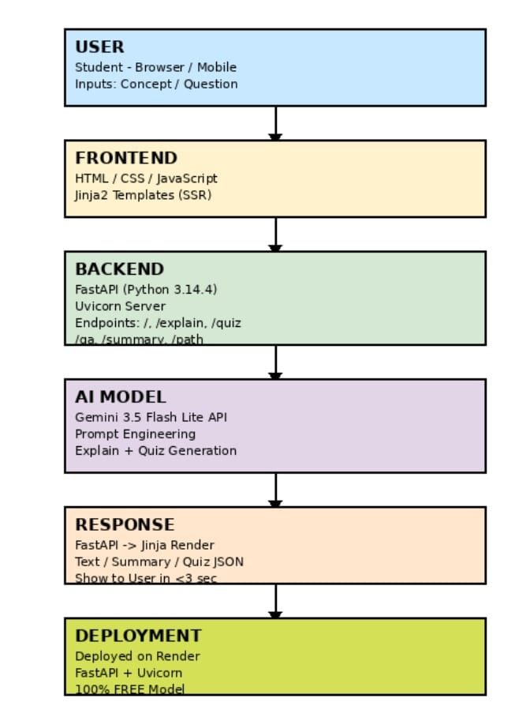
Data Flow:
1. Student enters concept in Browser
2. HTTP Request goes to FastAPI Backend (Python 3.14.4 + Uvicom)
3. FastAPI calls Gemini 3.5 Flash Lite API with engineered prompt
4. Gemini retuns explanation/quiz/ summary/qna/learning path
5. FastAPI fomats response using jinja2 template
6. Response rendered to user browser in <3 seconds
7. Process completes, ready for next request

